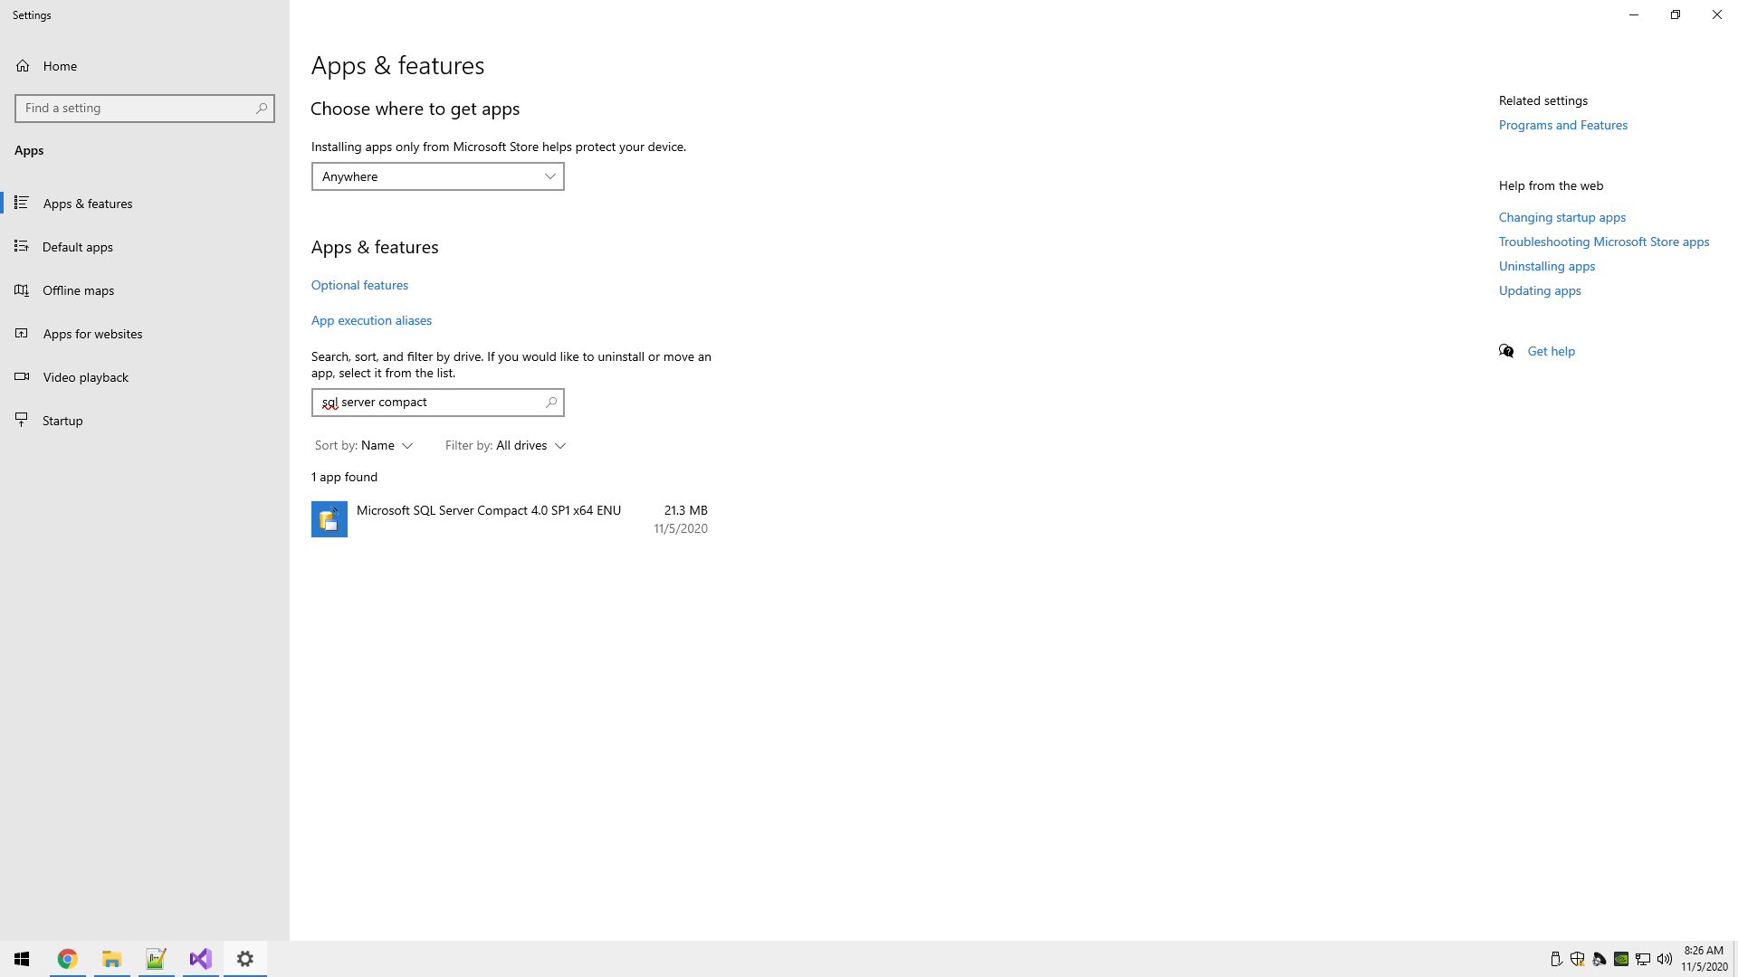

I installed SQL Server Compact Edition, but it isn’t obvious how to use it for me.

A lot of tutorials online say to use SQL Server Management Studio to access databases, but I don’t know if there’s another way by itself.

There’s no desktop shortcut.

No search results in windows start menu search.

There’s no .exe files to run.

In the installation folder there’s a readme page.

The readme file says it supports up to Windows 8.

In order to use the .dll’s, I need to have Microsoft Visual C++ 2008 Runtime Libraries (x86 and x64), Service Pack 1.

I didn’t know how to use a .dll file.

**I learned how to make and use a .dll file:**

Make a .dll by changing project settings and then building the solution.

Take the .dll file and add a reference to it using the reference manager, then import the file with a using statement and use the functions.

If the project setting for the application target framework is set to .NET Standard the .dll made will be usable within all .NET framework applications, unlike if the application target framework was set to .NET Core.

There is probably a way to use SQL Server compact with code and the .dll files.

Trying to add the .dll to my visual studio 2019 project didn’t work.

**I learned how to use SQL Server Compact with help from Lam** by watching this video: <https://youtu.be/Vbe_pAGP74c>

**I learned there are extensions and .DLLs that aren’t usable on newer versions of Visual Studio/.NET Framework.** In order to use SQL Server Compact I had to get Visual Studio 2015 to download the toolbox extension.

The toolbox can establish a DB connection to SQL Compact and generate SQL queries to make things easier.